WEB SERVER And APP SERVER

1. Install nginx and run nginx on port number 81.

To install:

Sudo dnf install nginx -y

To enable and start

Sudo systemctl enable nginx

Sudo systemctl start nginx

To Change port no to 81 we need to edit nginx configure file

Sudo nano /etc/nginx/nginx.conf

server {

listen 81;

listen [::]:81;

server_name _;

Save with Ctrl+o ,enter, ctrl+x

Reload nginx

Sudo sytemctl restart nginx

Then check

<http://local> host:81

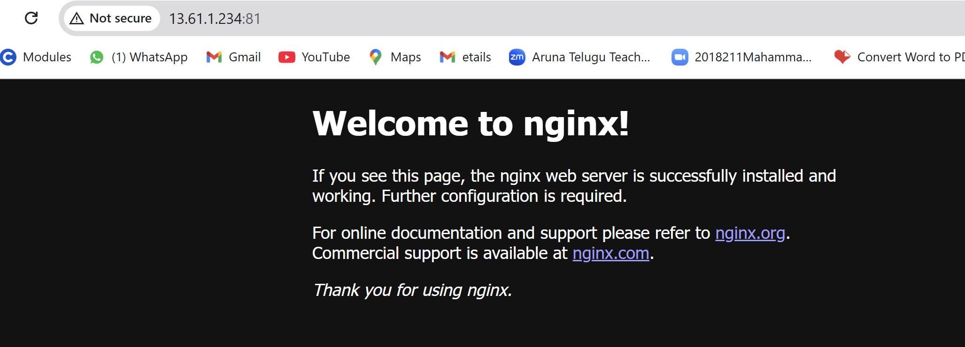

1. Deploy a sample index.html file on nginx.

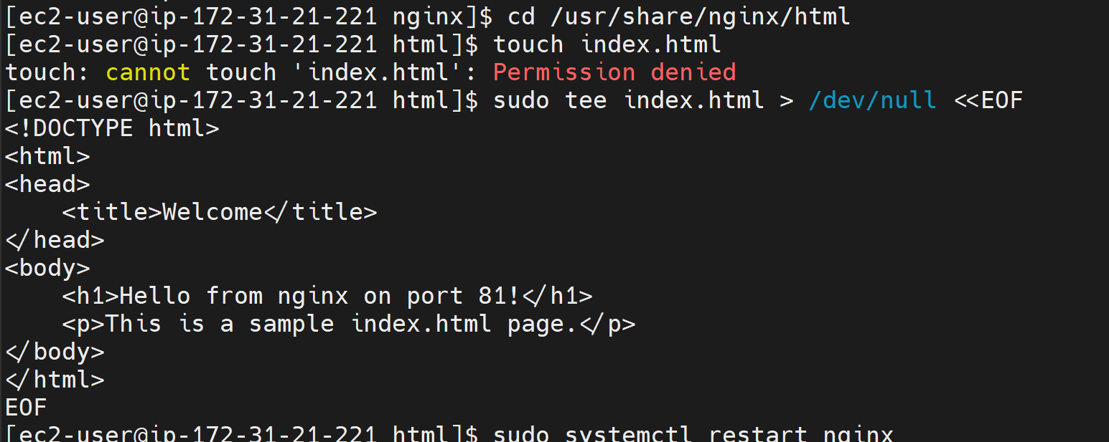

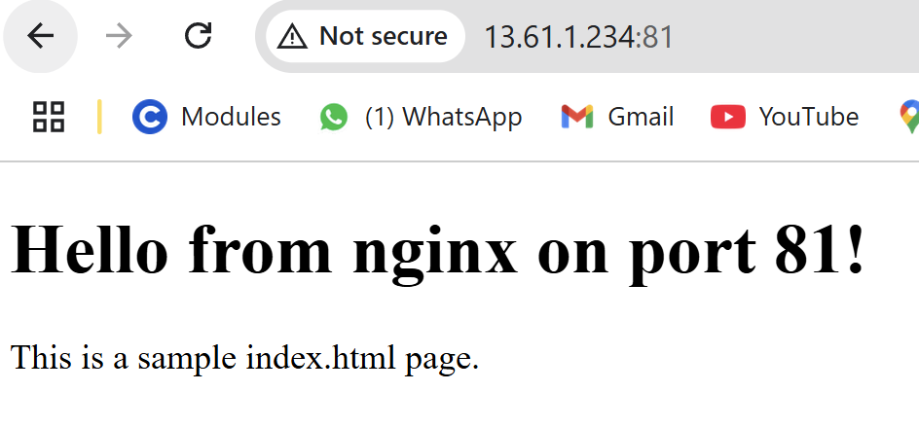

1. Install Apache and run Apache on port number 82

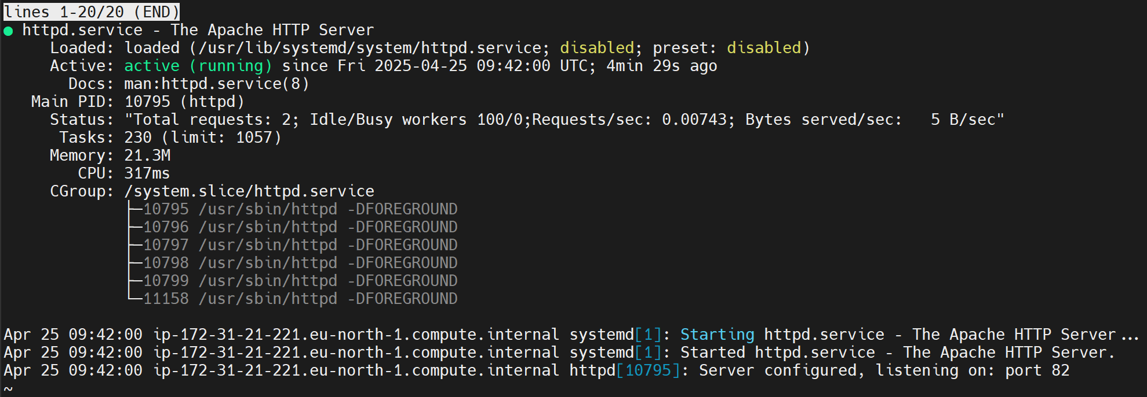

1. Deploy a sample index.html file on Apache.





1. Install Apache tomcat on port number 8082

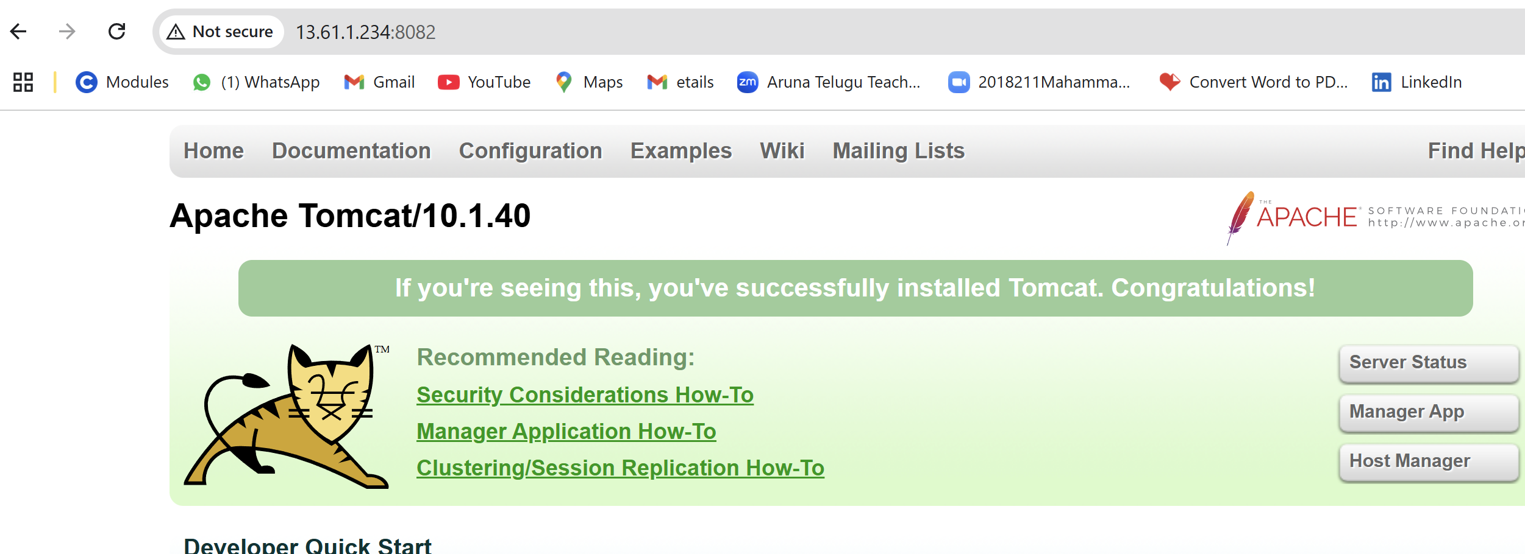

1. Deploy a sample app on webapps  
    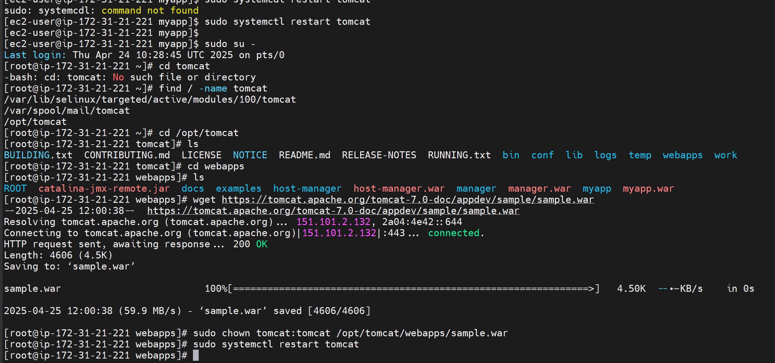

tail -f /opt/tomcat/logs/catalina.out

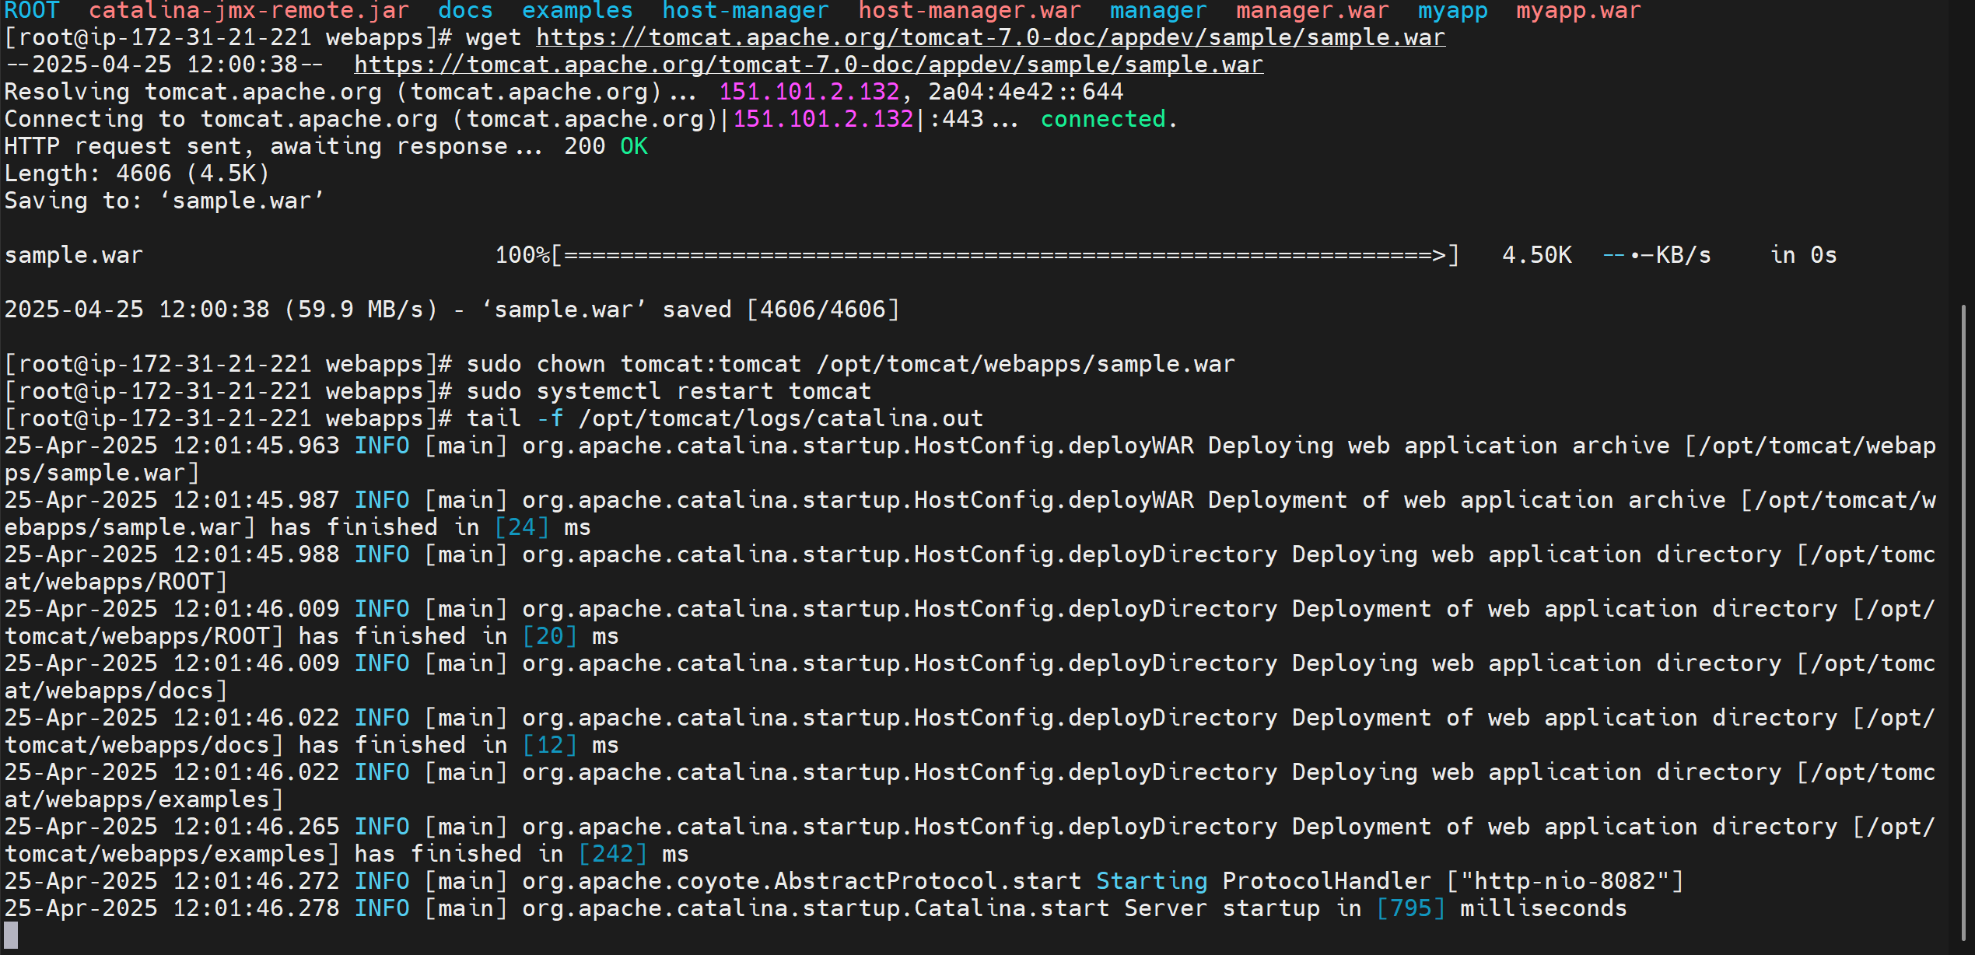

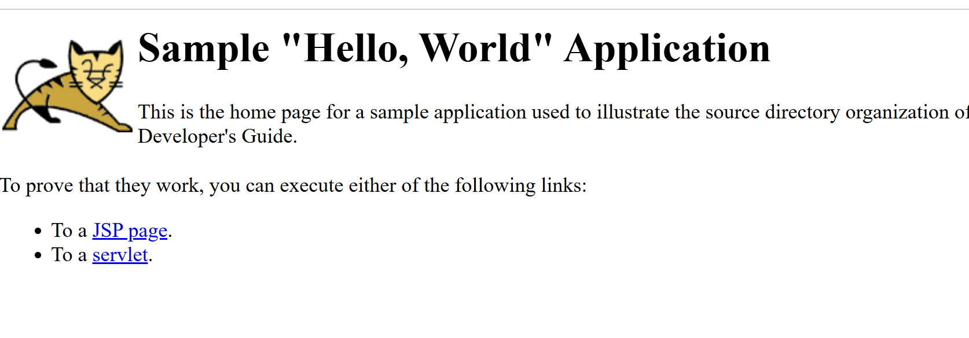

1. Create a tomcat.service file for tomcat.

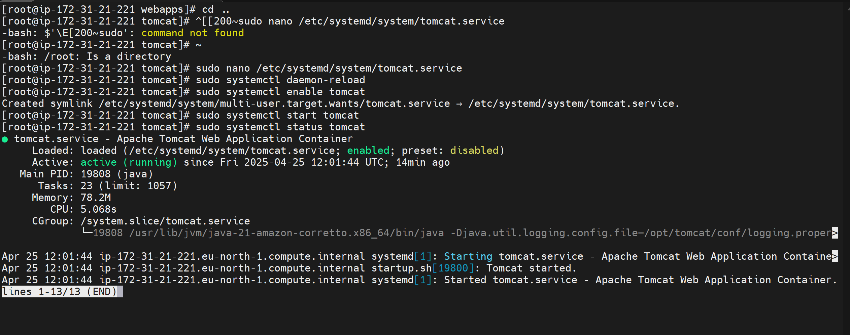

1. Configure HA Proxy server

